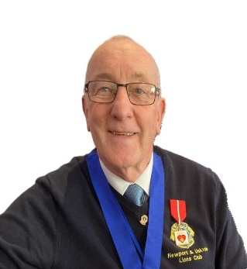
Lion Glyn Williams
Hello Fellow Lions, my name is Glyn Williams and I am a member of Newport and Usk Vale Lions Club. I came late to Lions International at the ripe old age of 54 when I moved to West Sussex, joining West Wittering Lions Club, but within two years I took early retirement after 30 years in a man’s dream job of working in sales for various breweries and then moving to Almeria in Spain.
Unfortunately at that time there were no clubs near to where we lived, but a conversation some years later with another ex-lion, soon turned into the Charter of a new Club and in 2012 Vera and District Lions Club was formed and I am proud to say that I became president in 2013,and the club today is still thriving with over thirty members.
On returning to the UK in 2014 my wife and I joined Chepstow and Caldicot Lions and I was extremely proud to be their Secretary and President until transferring to Newport and Usk Vale Lions in 2020.
Both clubs have given me the opportunity to gain the most valuable experience in Lionism you can get, currently with Newport and Usk Vale I am Secretary, Membership and Service Officer.
In 2018 thanks to Lion Sue Wilding I was asked to take up the role of Zone Chair and have continued in that role until 2022 when I was appointed Region Chair, a role that I feel most passionate about.
I am currently Region Chair for South Wales or Region D as it is known, and no I don’t speak Welsh. I have also been a guiding lion since 2022. Unfortunately my wife Kay passed to higher service in 2017, but my close family and family of Lions have encouraged me to continue my passion for lions.
I am passionate about being a Lion , passionate about service and dedicated to serving my fellow lions and community, and as Second Vice District Governor I would hope to bring that passion and commitment to the role.

Vera & District Lions Club
President 2013/2014

Chepstow and Caldicot Lions Club
Secretary 2016/2019
President 2019/2020

Newport and Usk Vale Lions Club
Secretary 2020/2024
Service Chair 2020/2024
Membership Chair 2020/2024

District 105CW Offices held
Zone Chair 2018/2024
Region Chair 2022/2024

