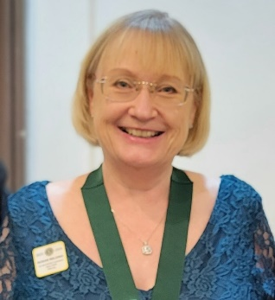
Susan Wilding

I joined Ross on Wye Lions Club in 2010.
I had been a ‘Lion’s partner’ for a few years and helped out when needed, but wanted to make a more active contribution to the Club and its activities. I have always enjoyed volunteering, I value the feeling that the little I can do could make a difference. Whilst my children were young, I volunteered on the school PTAs and later became a school Governor.

My professional career was in education, starting as a secondary school teacher in an East London school. From there I progressed to Birmingham working in schools north and south of the city. Moving to live in Ross on Wye I changed to work with children who had been excluded from school. Alongside teaching I used my earlier qualification in youth work to become a volunteer youth club worker, then coordinator and am now on the Management Committee.

In my personal life, I am married to Keith, who is a Past District Governor, and we have an expanding family of daughters, son, grandchildren and one great-grandchild. Each one brings great joy to our lives.

Being Membership Team Coordinator through the pandemic was a steep learning curve and offered a chance to embrace new ways of communicating. Through the power of zoom I have been able to talk to many great Lions and listen to their views and experiences. The power of social media has added to these new communication methods and WhatsApp is proving a great resource too for instant chat, ideas sharing, discussion and decision taking.

In July 2023 I took on the role of 2nd Vice District Governor. It has been a privilege to visit Clubs and hear of the great service our members give to their communities. I’ve been able to see Lions in a new light and meet up with old friends, make new friends and be enthused with the energy and interest of new members.

Our members are the strength of our Association, we bring our skills, talents, interests and diversity into our Clubs. New members help to build our resources and reinforce our resolve to fulfil our shared mission of Service. I continue to believe it is important to have a Positive mindset, to listen to each other and be open to sharing and learning together in the true spirit of friendship and cooperation.

I am proud to be a Lion and a member of a Club in this District. We are now established and building a good reputation as District CW. I will always aim to do my best for this District and all its members, in whatever way I am asked to Serve..

Life as a Lion
Ross on Wye Lions Club
Joined 2010
Club President 2013 – 2014
I have taken the role of Chairperson of all the main Committees of the Club: Activities, Community Services, Membership and Entertainment. For several years I led the Club’s Annual Beerfest and the Pancake Race event. Currently I have responsibility for Club Publicity and Social Media as well as jointly overseeing the running of the Club’s charity shop.

District Roles
Zone Chair
Young Leaders in Service
Competitions
Membership – Global Membership Team Coordinator (GMT).
2nd Vice District Governor 2023-24
I have presented in training and workshop sessions, at Forums and Conventions on topics including Facebook and Social Media, Competitions, Incoming Officers Membership, New Voices, the Global Membership Approach and Building Stronger Clubs.

Multiple-District Roles
Young Leaders in Service MD Deputy
Membership – MD Deputy and then MD GM Team Lead
Presented on Membership at Governor Training sessions, Council meetings and Conventions. Ran online sessions and “Membership Bootcamp” 2020.

Attended Europa Forum in Maastricht and Birmingham and International Convention in Hawaii.

