Using the right logo:

Using the right Lions international is extremely important.
A logo is a clubs first introduction to public
The purpose of a logo is to give a visual representation of your brand.
Your logo should promote your business and build brand identity.
In the case of Lions, it connects your club with the wider organisation of Lions.
When you use the Lions logo it is not just representing your Club but the whole of Lions.
When you wear or use the Logo you are Lions international.
Therefore, using an old logo gives the public confusing and mixed messages.

Wrong and old logo: Right logo:

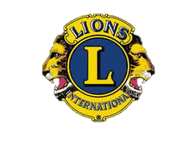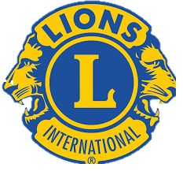

If you are making your own logo, please ensure you have the right Lions International logo included in there.
Using the right logo helps us spread the brand and hopefully remove the secret part of Lions

Got any questions? Email: pr@lions105cw.org.uk

#TeamCW
