Why coming off E-clubhouse may be more beneficially for your club:

When we think Lions websites many of us think of E-clubhouse.
However, having used E-clubhouse I can see how many Lions are frustrated with it.
We are unsure about the future of E-clubhouse, so why not take the control back into your hands?

Below are some of the benefits of coming off Clubhouse:
- You can control your website
- You can multiple pages that are easier to navigate
- You control all the content and the look of your website
- Easier to manage and edit and is mobile friendly
- You can add videos and better-quality photos
- It’s easier to link all your social media
- You can have cool features such as live updates, hover buttons etc

Below are some of the disadvantaged of coming off Clubhouse:
- It’s free
- Built in members only features
- Built in links to other areas such as international
- You’ll have to build your new website often from scratch and this takes time.

If you do decide to come off E-clubhouse I would recommend clubs to use a website builder. These often have templates you can change to sit your club.
Often, they will offer a package deal with benefits (such as being ad free) and will give you a domain.
(See the domain guide for further support).

If you do wish to leave E-clubhouse please note you cannot delete your E-clubhouse account. You can however, delete all pages except home, delete all home content and leave a link to new website.

Also, to note that if you build your new website it takes time to get your new website to the top of any search engine.
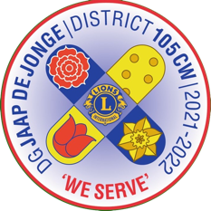

Got any questions?
Email: pr@lions105cw.org.uk

#TeamCW

