Domino Effect:

A domino effect or chain reaction is the effect produced when one event sets off a chain of similar events.

In PR terms there are two types of Domino Effects: Good and Bad.

Good Domino Effect:

A good domino effect sets off a series of good consequences. For example, you share a fantastic piece of service you have done, one person shares this then another and before you know you have a great reputation. This is something all clubs should be aiming for.
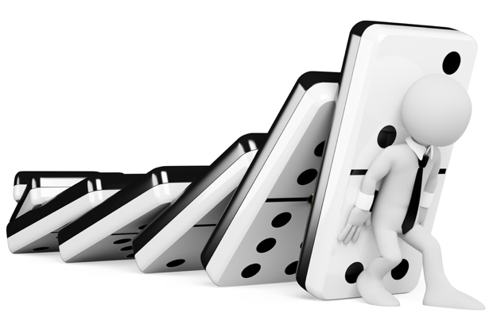
Bad Domino Effect:

A bad domino sets off a series of bad consequences. For example, a member of the public doesn’t like your club (could be from an experience, observation etc), they then tell another person. The other person then tells another and so on and so on. Leaving your club in a PR nightmare and bad light.

So how do you prevent starting bad domino effect?

Essentially, we need to think of ourselves as a business. When we are wearing a Lions logo, we are representing all Lions.
Therefore, we need to be friendly, professional and most importantly fun.
We need to leave personal grudges and negativity away from the public.
If we go to meet anyone, we need to wearing a Lions badge.
If we are making posters they need to be a great quality with the right logo on and not look like it’s been photocopied.

Good Luck and hopefully this has helped with avoiding negative domino effect.

Got any questions? Email: pr@lions105cw.org.uk

#TeamCW
