Membership Recruitment – a Resource for your Club
Dear Lions
Your Membership Team wish you well as we continue through these difficult times.
As we move into summer, we are thinking of how we could be able to meet more Lions and non-Lions face-to-face. There might be opportunities to tell people about volunteering with and within Lions Clubs.
Here is something to help you in your recruitment activity
‘Contact Us’ cards.
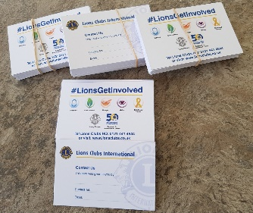
These are designed to be carried by your members – in their wallet, in their purse or in their pocket. They carry the logos of our key Service Areas plus the Lion logo and LCIF logo- a great aide memoire when explaining what Lions is all about.
The ‘Contact Us’ side allows any Lion to fill in details so the card can be handed to any interested non-Lion during or at the end of a conversation.
Please use these cards – share them out amongst your members to help them in recruiting New Members.
If, by any chance, your members do not feel they can use these cards effectively, please give them to your Zone Chair so they can go to another Club.
If you would like more cards, please contact MDHQ for details of how to buy some
Good luck with your Recruitment Activity – Lets Grow Together!
GMT Committee Lead | Sue Wilding
Deputy | Richard Williams
Young Farmers | David Houghton  Michael Berry
Almoner | Adrian Hutchings
Membership PR | Can Ulugtekin
New Voices coordinator | Leonie J. Seymour-Milsom
Leos and campus clubs | Stewart Sherman-Kahn
Competitions | Sue Wooldridge
Sue Wilding – 105CW gmt@lions105cw.org.uk

Your Membership Team

